JHSC meeting IWTV 3 September 18 2025
Location: 6115 Edwards Blvd
Time: 10:00 – 10:45
Co-Chairs: M. Gugliuzzi, R Warren
Attendance
R Warren -W, M. Gugliuzzi – E, N. Lane – E, A. Byrne – W, C. Warren -W, M MacGregor – Jordan Stephens
Agenda:
Review minutes of July 28 2025
Minutes Approved
New Business
August 6 - AMC site visit. A onsite safety check and security audit was conducted at 6115 Edwards st. We are expecing a report and reccomendations from their consultants to implement.
August 12 – Safety meeting took place in the boardroom with all HOD’s and Production to discuss the safety concerns and logistics issues regarding Bluffers Park shoot. Transport dept to coordinate with shooting crews to move equipment. Key Grip (Adam McDonald) to monitor wind speeds and responsible to make call if speeds exceed 22mph. Risk Assessment provided by HOD’s and Pegasus was reviewed. Section 21 Film guidelines will aslo be distributed to crew.
AC units have been installed and new security fences are now placed around units. Placards have been applied to units outlining proper procedures for start up and shut down to avoid uneccsay service calls
Washrooms – A sudden spike in eOHS reports required a JHSC investigation involving locations and cleaniing contractor. It was determined that onsite inventory needed to be increased for additional soap, toilet paper, and handtowels. It was also discovered that 2 of the automatic soap dispensers were in need of replacement. Soap dispensers will be repaired or replaced by building manager. Large pump bottles of hand soap have been added to washrooms with defective dispensers in the mean time. Cleaning contractors will now scan the QR code when cleaning/restocking is completed so we can monitor intervals between cleaning a crew concerns.
Satelite crew parking at Roots – Received a safety report (Aug 19 eOHS report # 1406) that gas had been siphoned from a crew members car. Investigation completed to find other crew members may have had suspicious activity around their vehicles also but unforunately no reports were filed. It was determined this was an isolated case and no increase in security was warranted at this time.

Injury Reporting
Some departments are not utilizing the eOHS injury reporting system and instead emailing Production directly for WSIB forms. This has caused delays in JHSC investigation and WSIB filing when required. Departments are reminded to file all injuries with the medic so proper protocols can be followed.
WSIB safety check
Since the introduction of eOHS we have received over 200+ injury reports. The severity ranging from minor cuts and scrapes to sprained ankles. WSIB reporting was required in only 14 of the reported injuries or 7 % with only 6 being loss time claims. Current reporting and resolutions processes for JHSC injury investigation has reduced the workload significantly and will continue. The Construction Department accounts for 2/3’s of all claims.
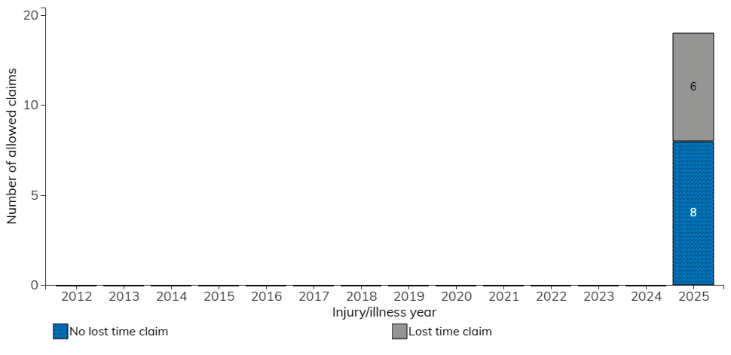
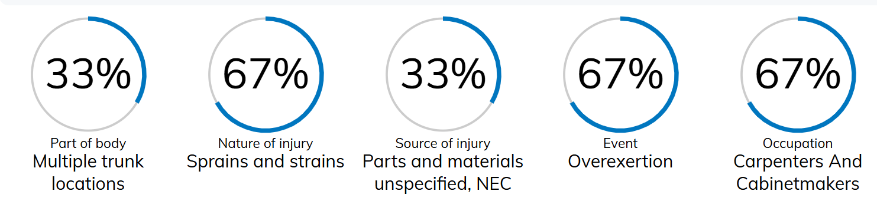

Recommendations to Employer: None
Next Meeting date: TBD
Adjourned 10:55 am

